EX.NO: 02 REGRESSION AND OPTIMISATION
DATE: 28.01.26 [LINEAR AND LOGISTIC REGRESSION]

SCENARIO 1 : OCEAN WATER TEMPERATURE
PLOT:
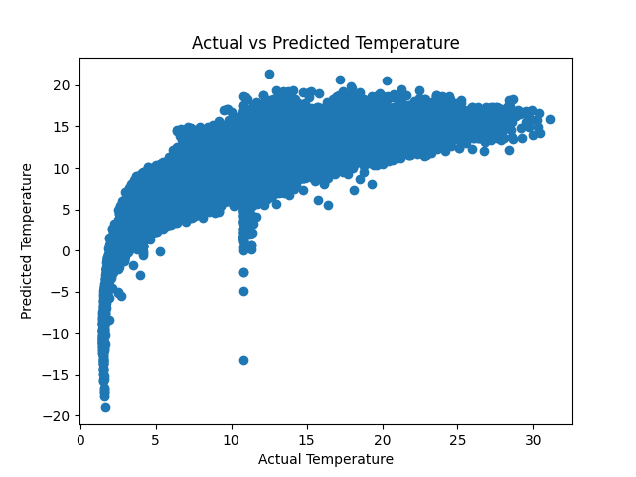

MSE : 6.221446882618067
RMSE: 2.4942828393384073
R² : 0.6492792001567061

SCENARIO 2 : LIC STOCK PRICE
CONFUSION MATRIX:
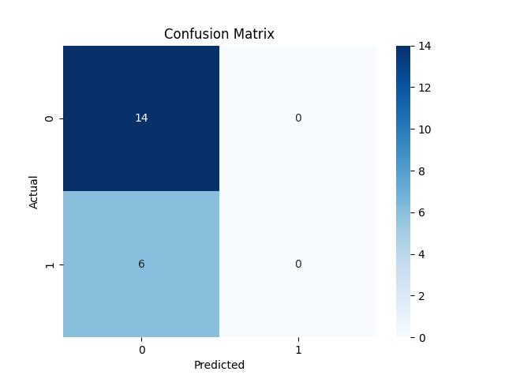
ROC CURVE:
